How Budget Influences Horror Narratives?
A Text Mining Study of Horror Movie Descriptions (TMDB)
Assignment 2 — Natural Language Processing — EDHEC Business School — Ricardo Padilla Herrera

OBJECTIVE & BUSINESS RELEVANCE

This study investigates whether production budget influences how horror movies are described in their marketing text. Movie overviews are key informational assets on both streaming platforms and theatrical releases: they shape audience expectations, affect click-through decisions, and signal the type of horror experience the viewer can expect (for example supernatural, investigative, or psychological horror). By comparing high-budget and low-budget horror descriptions, this analysis aims to identify systematic differences in narrative framing that may inform metadata writing, catalog curation, and recommendation strategies for content platforms.

DATA
The corpus is constructed from the TMDB Movies Dataset (2023) available on Kaggle (Asaniczka, 2023). The overview column is used as the primary textual corpus because it corresponds to the marketing synopsis presented to users.

Before genre filtering, the dataset was cleaned to ensure valid observations. Rows with missing overview, genre, or budget values were removed, budget and revenue variables were converted to numeric format, and films with non-positive or placeholder budgets (< 10,000 USD) were excluded. Extremely short descriptions were also discarded to avoid non-informative documents. These steps ensured that the corpus contained meaningful and comparable movie descriptions.

Filtering steps applied:
- Only films labeled with the Horror genre were retained.
- Only films released after 1975 were kept ensuring comparability of modern descriptions. The year 1975 was selected because it marks the beginning of the modern blockbuster era, allowing comparison between films produced under similar industrial conditions.
Films were divided by budget percentile:
- Low budget: ≤ 20th percentile
- High budget: ≥ 80th percentile

The overview field is particularly suitable for text mining because it is a standardized short-form narrative description written to summarize the story and attract viewers, making it comparable across films and appropriate for thematic analysis.

TEXT PREPROCESSING
Without preprocessing, high-frequency grammatical words and inflected word forms would dominate token counts and obscure meaningful thematic patterns. The cleaning and normalization steps therefore aim to reduce linguistic noise and ensure that frequency distributions reflect narrative content rather than writing style.
An 8-step preprocessing was applied:
# | Step | Purpose / Rationale
1 | Lowercasing | All text was converted to lowercase to ensure that words such as Ghost and ghost are treated as the same token.
2 | Noise Removal | Regular expressions removed URLs, punctuation, numbers, and special characters:
3 | Tokenization | The cleaned text was split into words using NLTK’s word_tokenize, converting each description into a list of tokens.
4 | Stopword Removal | English stopwords from NLTK were removed because they carry grammatical rather than semantic information and dominate frequency distributions.
5 | Domain Stopwords | In addition to standard English stopwords, a domain-specific stopword list was created containing generic movie-description terms (film, movie, story, year, man, woman). These words occur in nearly every overview and therefore add frequency bias without contributing to thematic differentiation.
6 | Short Token Filter | Tokens shorter than three characters were removed to eliminate linguistic artifacts.
7 | Lemmatization | Reduces tokens to their dictionary base form for consistency.
8 | POS Filtering | Retains only nouns and adjectives. Nouns and adjectives better represent themes, entities, settings, and atmosphere (host, demon, haunted, dark). This step improves interpretability of word frequencies and visualizations

QUANTITATIVE TEXT ANALYSIS

Document Vectorization
The cleaned descriptions were transformed into numerical representations using a Bag-of-Words model (CountVectorizer). Each movie overview was represented as a vector of word counts. Extremely rare words (appearing in fewer than five documents) and extremely frequent words (appearing in more than 85% of documents) were removed to reduce noise. This produced a sparse document-term matrix suitable for quantitative comparison between the two corpora.

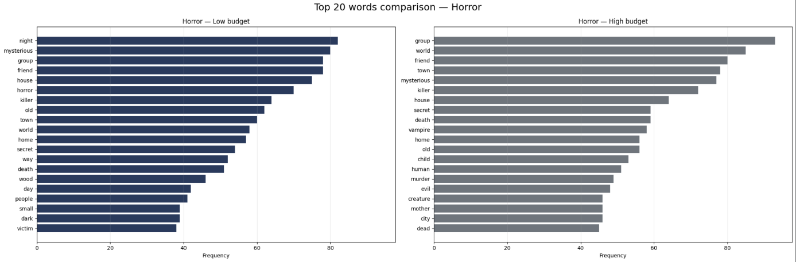
Word Frequency

Both corpora share core horror vocabulary such as night, house, death, and kill, confirming consistent genre conventions. However, differences appear in narrative focus: low-budget films emphasize individual characters and close social relations, while high-budget films more often reference groups and locations, suggesting a broader narrative scope and more complex story settings.

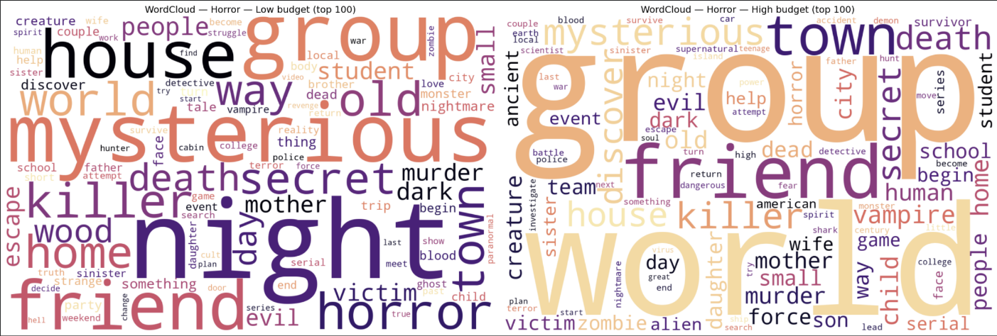
Word clouds

The word clouds reinforce this contrast visually. Low-budget descriptions concentrate on intimacy, domestic spaces, and immediate danger, indicating contained stories centered on personal survival. In contrast, high-budget descriptions highlight places, collective actors, and external threats, reflecting larger environments and more expansive world-building.

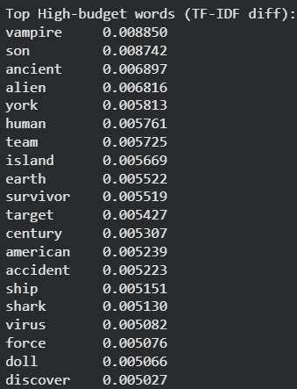
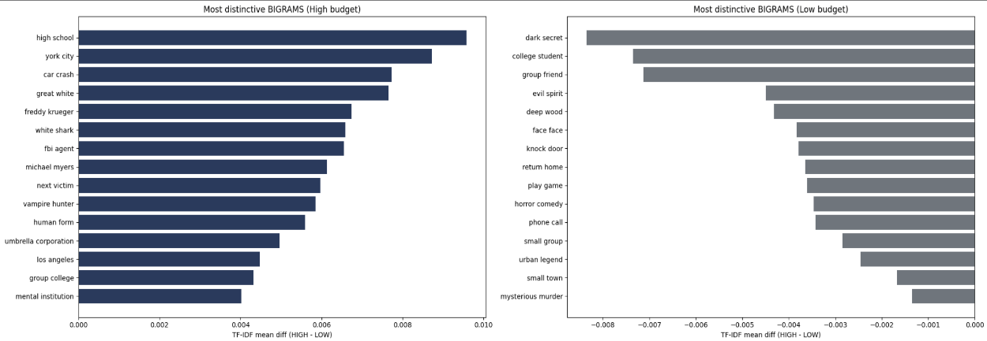
Bigrams and TF-IDF

Distinctive vocabulary confirms structural differences between the narratives. High-budget films frequently reference institutions and specific locations, while low-budget films emphasize actions and direct encounters. This indicates that larger productions build broader narrative worlds, whereas smaller productions rely on immediate conflict and interpersonal threat.

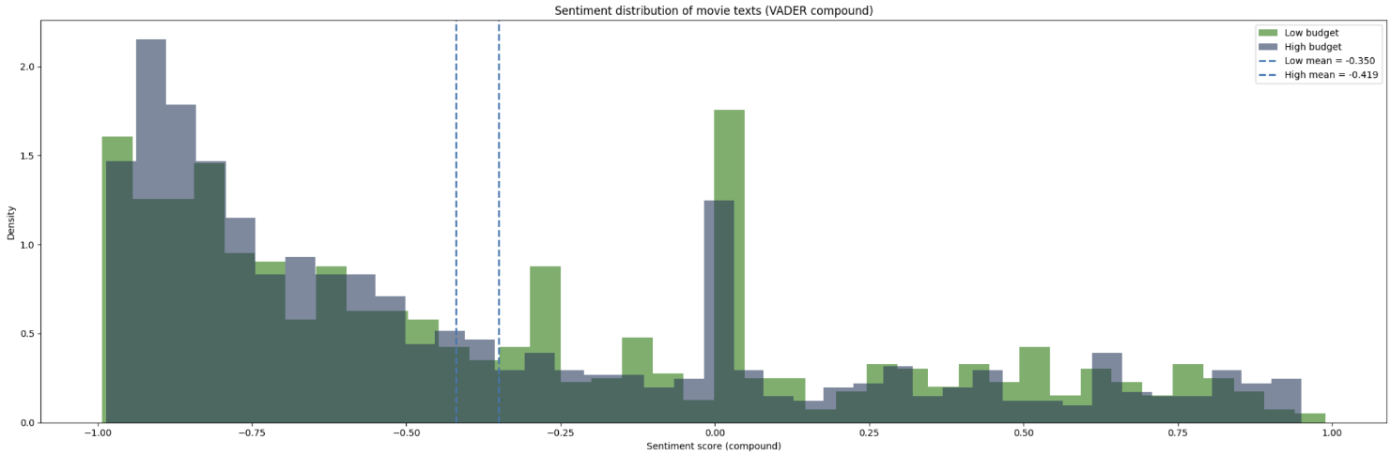
Sentiment Analysis

Both groups exhibit an overall negative tone consistent with the horror genre. However, high-budget films show slightly stronger negative sentiment, suggesting that their descriptions portray more intense or severe threats, supporting the idea of higher narrative stakes.

INTERPRETATION

Taken together, the results show a consistent pattern. Production budget does not change the core vocabulary of horror, which remains centered on fear, death, and supernatural threat. Instead, budget changes how the story is framed. High-budget films tend to describe broader worlds involving locations, groups, and institutions, whereas low-budget films emphasize proximity, isolation, and direct personal danger. The narrative scale therefore expands with production resources.

CONCLUSION
This study demonstrates that budget influences narrative framing rather than genre content. While both groups share core horror vocabulary, the results show that high-budget films more frequently reference locations, groups, and institutions, whereas low-budget films emphasize personal encounters and immediate danger. Bigram and sentiment patterns further suggest broader narrative scale and slightly stronger threat intensity in higher-budget productions. These differences indicate that marketing communication should vary by production scale: large productions can be promoted through spectacle, world-building, and investigation, while smaller films benefit from emphasizing tension and proximity. Such insights are relevant not only for streaming platform metadata and recommendation systems, but also for theatrical marketing materials such as trailers, posters, and synopsis writing.
REPRODUCCIBILITY & DATA ACCESS
Data Source
Asaniczka. (2023). TMDB Movies Dataset (930k movies). Kaggle.
https://www.kaggle.com/datasets/asaniczka/tmdb-movies-dataset-2023-930k-movies
Due to the dataset size exceeding the upload limit, the data is hosted externally and automatically downloaded within the notebook using a public Google Drive link. Running the first cell fully reproduces the analysis without manual data handling.
Direct access to the dataset:
https://drive.google.com/file/d/1EbZeuO5agx1U7bJoJJokgZbYvpXwB9IR/view?usp=sharing

